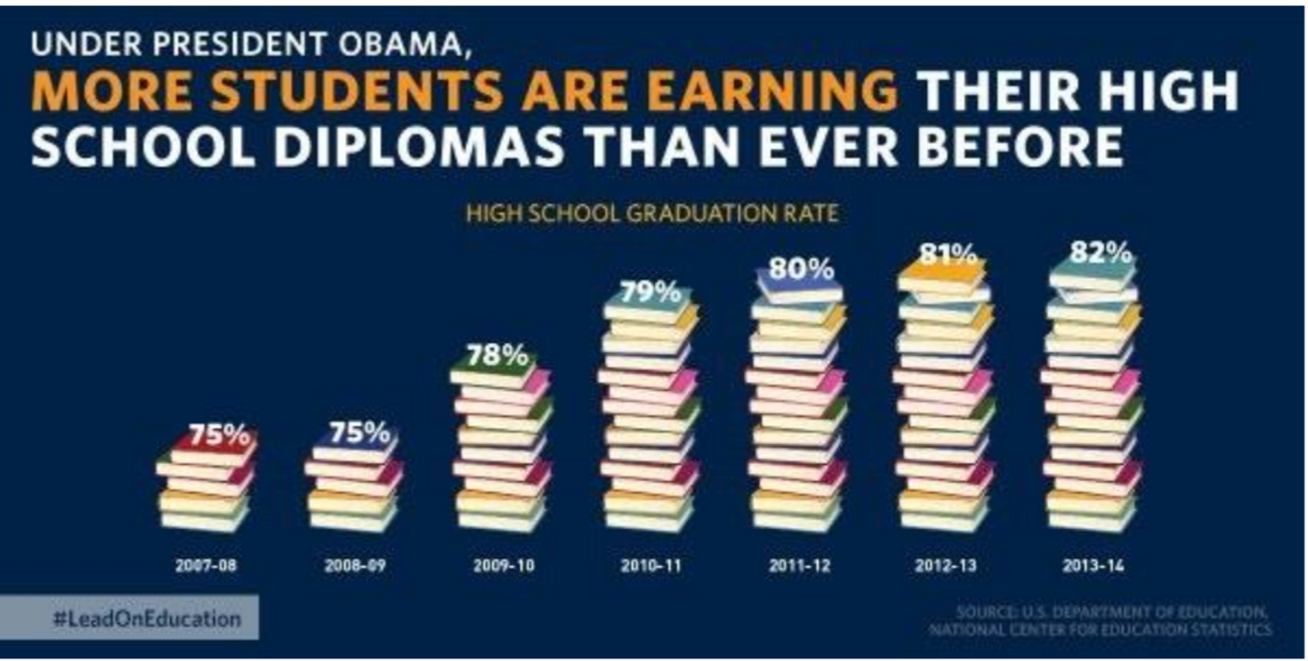

Problem:

This bar graph uses books to indicate the percentage difference between high school graduates per school year, but these books make it difficult to interpret. Specifically, the heights of the books are inconsistent and misrepresent the data. For example, the difference between 2009-10 to 2010-11 depicts a large difference compared with 2012-13 to 2013-14 even though the numerical difference is the same.

Solution:

To fix this graph, I would first use bars instead of these books to make the columns easier to compare. Then add a proper y-axis with proper labels and guidelines so you can remove the percentages from the tops of each column which would make the graph more readable.

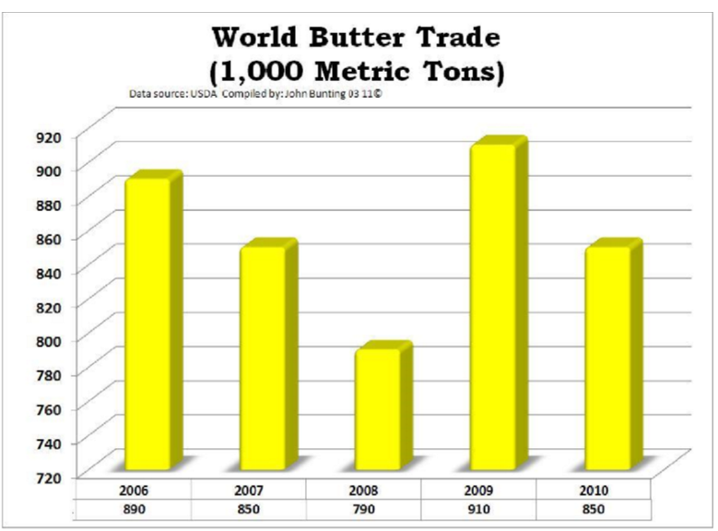

Problem:

The first problem with this graph is that its readability is poor, even with guidelines, because they slant as they approach the y-axis making it hard to make out the heights of the bars. The other problem with the graph is the unlabelled values under the years, at first glance, they were random numbers, then after some thought, they appear to be the bar heights.

Solution:

The solution to these problems is to make the graph 2D, this makes it easier to line up bars with the guidelines which will make it easier for the observer to read. With this change, the values under the year become obsolete since the values of the bars will be easier to see so they can be removed.

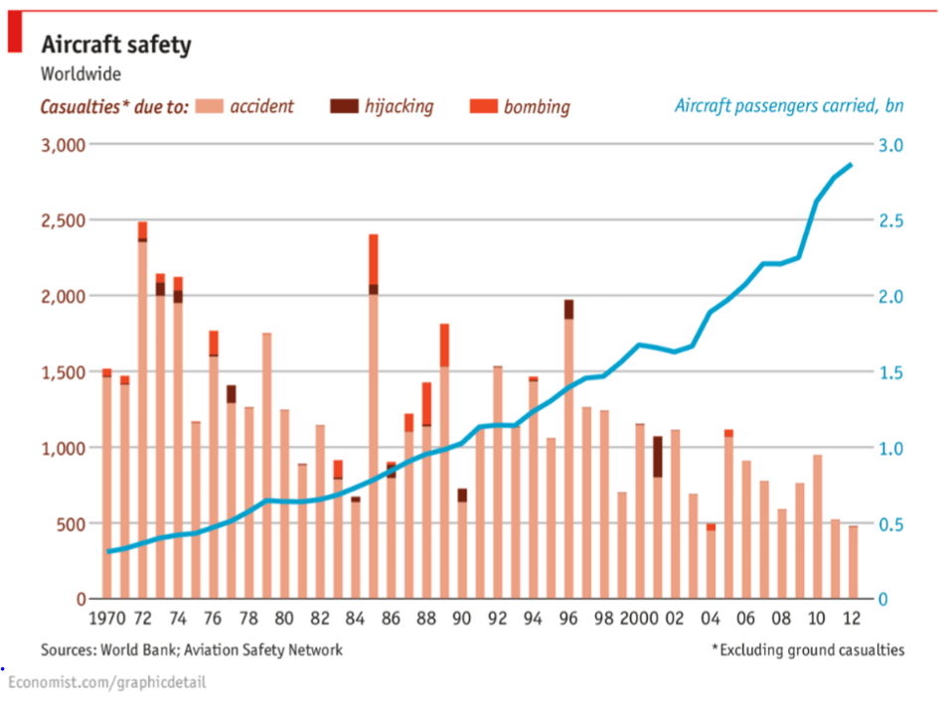

Problem:

A problem I see with this graph is the label, “Aircraft passengers carried, bn” which is confusing to someone outside of this industry, especially when the right axis has a range from 0 to 3. Even after googling its unclear what metric is being used to measure the number of aircraft passengers.

Solution:

A fix to this problem would be to simply re-word the label so that it makes more sense to the general viewer. Another fix to this problem could involve defining what bn means or changing the metric used to measure aircraft passengers carried altogether.

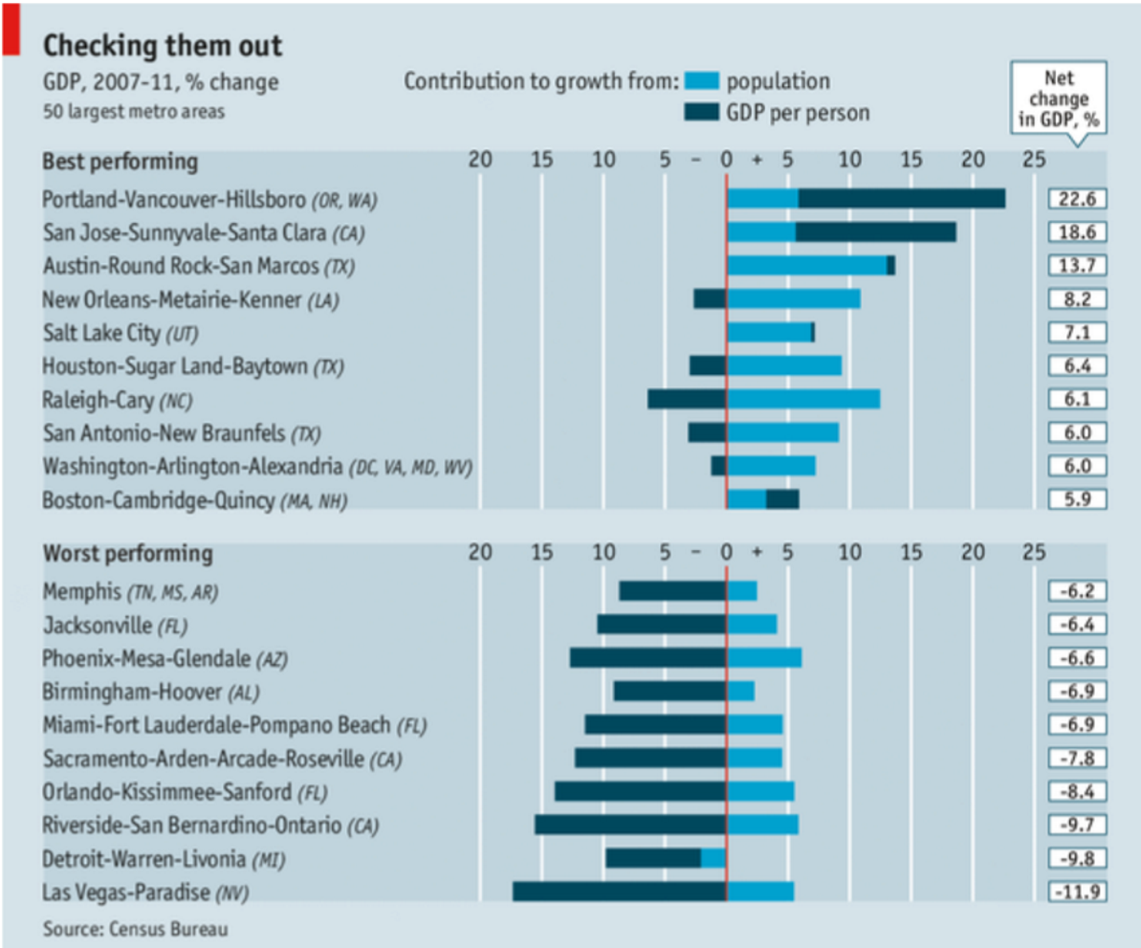

Problem:

A problem I see with this plot is the title “Checking them out”. This title is uninformative to the observer and doesn’t contribute any additional information about what the graph is about, which is missing slightly.

Solution:

The solution to this problem is adding a proper title. This could include explaining where in the world these cities are, what the graphs are measuring, and generally what this plot is trying to convey to the people who will be seeing it.